**1.Feedback analysis:**

Holder provides a lot of valuable data, but most of them are related to the course itself and user attributes, and less about user experience. Considering that the results of user experience will play a good publicity effect, so I collected the feedback data other than the data provided by the holder, conducted some expansion analysis, and independently mined the user experience.

Feedback analysis steps:

1. I manually crawled the comments from the course website and gather all the comments into one file. After that, I classified all comments by star rating.

2. Separate each sentence by comma, period and space to get the total word list

3. Data cleaning and statistics are carried out at the same time. After the high-frequency words in the list are counted, the meaningless words are judged subjectively and eliminated by my view, and then the statistics are made again to get the valuable hot word ranking

4. Display the data visually: display the statistical data and the words itself with the histogram and the word cloud chart respectively.

Results：

Overall speaking: 5 star rating comments dominate the whole comment situation.

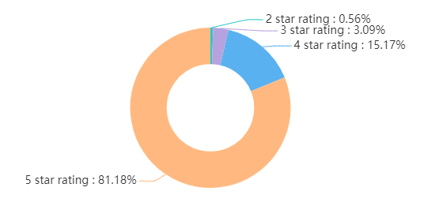

The statistics for all comments:

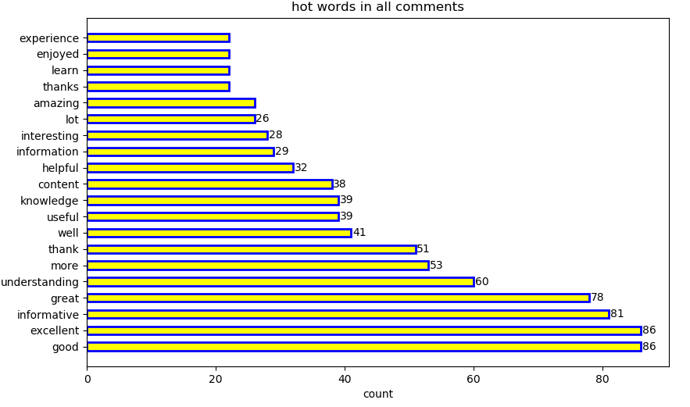

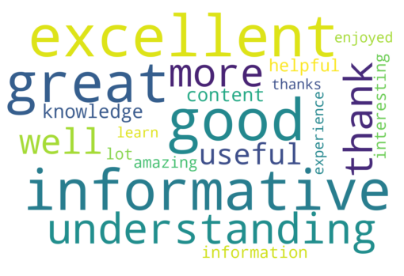

The statistics for 5 star comments:

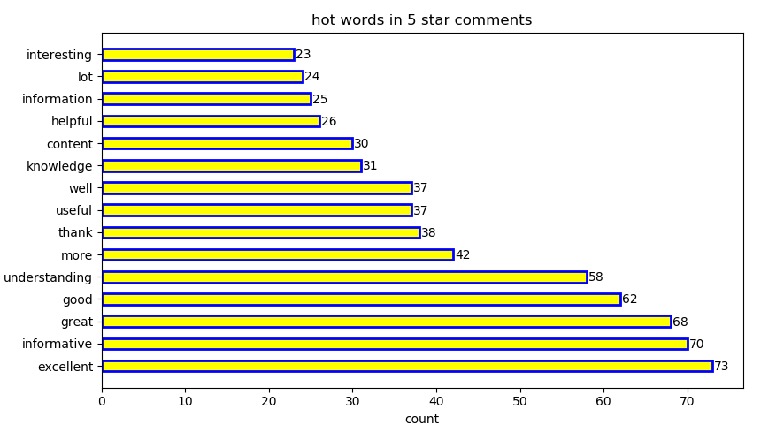

(‘excellent‘ is the most popular word in five-star reviews)

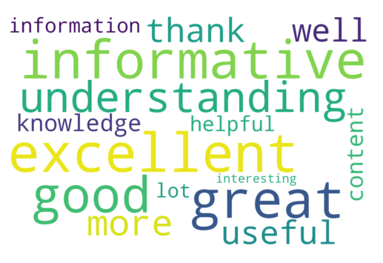

The statistics for 4 star comments:

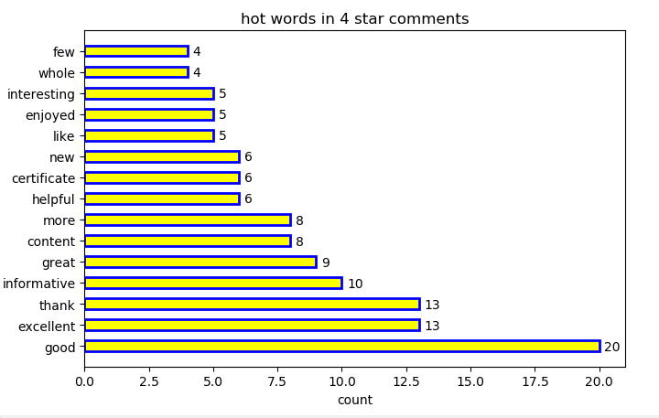

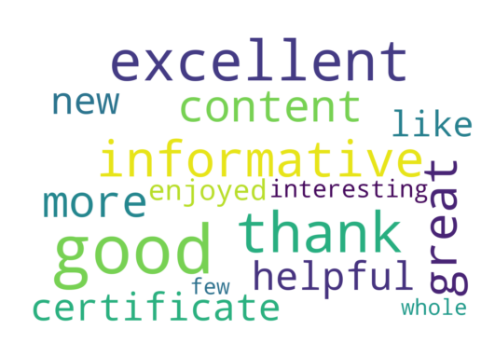

**2.Other hypothesizes and arguments:**

1. the distribution for enrolments by age shows that people aged 18 to 35 account for a large proportion.

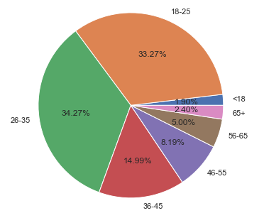

2. Visitor count and completion rate are negatively correlated, because people always look at the profile before deciding on a deep experience.

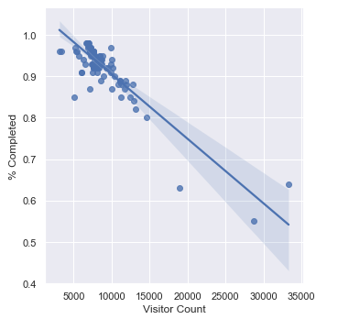

3.  Step and visitor count are negatively correlated.

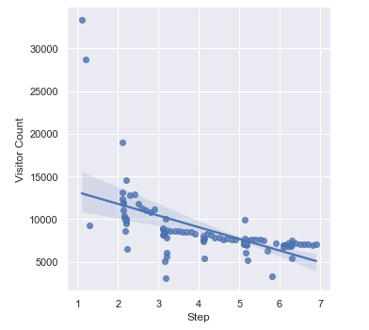

4. The more the course goes to the follow-up step, the users who are impatient or think the course is useless will lose. Therefore, **the average degree of love of the remaining users will be very high, so the completion rate will increase.**

